Scott Grosscup

Office (970) 945-6546

Direct (970) 928-3468

sgrosscup@balcombgreen.com

July 14, 2017

*Via U.S. Mail*

|  |  |  |  |  |
| --- | --- | --- | --- | --- |
| Kelly Sheridan  P.O. Box 865  Meeker, CO 81641 |  | Benjamin J. Rogers  P.O. Box 1083  Meeker, CO 81641 |  | Walter N. Proctor  P.O. Box 642  Meeker, CO 81641 |
| David Smith, Jr.  P.O. Box 359  Meeker, CO 81641 |  | Kai M. Turner  45840 Highway 13  Meeker, CO 81641 |  | Shawn Welder  P.O. Box 2318  Meeker, Co 81641 |
| Paul Neilson  P.O. Box 656  Meeker, CO 81641 |  | Bailey Franklin  P.O. Box. 1236  Meeker, CO 81641 |  |  |

**Re: July 22, 2017 Meeting**

Dear Directors:

Enclosed are meeting materials for the next meeting of the Yellow Jacket Water Conservancy District, to be held Thursday, July 20, 2017 from 2:00 to 4:00 pm. The meeting will be held at the Meeker Libarary, 490 Main Street, in Meeker, CO.

Craig Ullman with Applegate Group will be present to discuss the status of ongoing reservoir feasibility study. This includes their analysis on using a canal to fill the Tom Little Reservoir vs. a pump station on the White River as well as updated information on the future augmentation needs within the District’s boundaries. Copies of these reports are included for your review.

The Board will also be updated on discussions with the White River Electric Association and potential hydropower uses on the Highland Ditch as well as discussions with Augustus Energy on potential use of the District’s water rights in gas exploration and development.

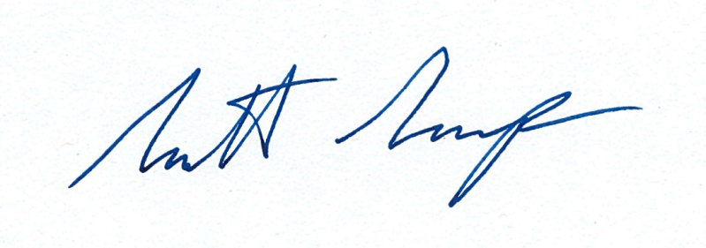Sincerely,

Scott Grosscup