Scott Grosscup

Office (970) 945-6546

Direct (970) 928-3468

sgrosscup@balcombgreen.com

December 2, 2019

|  |  |  |  |  |
| --- | --- | --- | --- | --- |
| Kelly Sheridan  843 County Road 6  Meeker, CO 81641 |  | Benjamin J. Rogers  P.O. Box 1083  Meeker, CO 81641 |  | Walter N. Proctor  P.O. Box 642  Meeker, CO 81641 |
| David Smith, Jr.  P.O. Box 359  Meeker, CO 81641 |  | Bailey Franklin  P.O. Box. 1236  Meeker, CO 81641 |  | Shawn Welder  P.O. Box 2318  Meeker, Co 81641 |
| Paul Neilson  P.O. Box 656  Meeker, CO 81641 |  | Anthony R. Theos  P.O. Box 267  Meeker, CO 81641 |  |  |

**Re: Board Meeting – December 5, 2019**

Dear Directors:

Enclosed are materials for the Board meeting for the Yellow Jacket Water Conservancy District for Thursday, December 5, 2019 at 3:00 p.m. The meeting will be held at the Meeker Public Library and will be open to the public.

The meeting will include discussion and approval of the 2020 budget. Director Proctor proposed consideration of a modificiation ot the District’s boundaries so that those district’s in the Yamba basin be either removed or transferred to another water conservancy dsitrict. Also enclosed are maps showing the potential affected areas and a memorandum describing the process. It also consinders funding of additional engineering expenses for support of the District’s study in how to best use its conditional water rights.

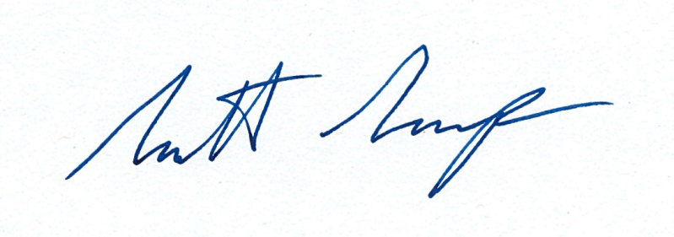Sincerely,

Scott Grosscup