|  |  |
| --- | --- |
| Balcomb LetHead Logo 2.jpg |  |
|  | Scott Grosscup  Direct Dial (970) 928-3468  Receptionist (970) 945-6546  sgrosscup@balcombgreen.com |
|  |  |

November 30, 2016

*Via U.S. Mail*

|  |  |  |  |  |
| --- | --- | --- | --- | --- |
| Kelly Sheridan  P.O. Box 865  Meeker, CO 81641 |  | Benjamin J. Rogers  P.O. Box 1083  Meeker, CO 81641 |  | Walter N. Proctor  P.O. Box 642  Meeker, CO 81641 |
| David Smith, Jr.  P.O. Box 359  Meeker, CO 81641 |  | Kai M. Turner  45840 Highway 13  Meeker, CO 81641 |  | Shawn Welder  P.O. Box 2318  Meeker, Co 81641 |
| Paul Neilson  P.O. Box 656  Meeker, CO 81641 |  | Bailey Franklin  P.O. Box. 1236  Meeker, CO 81641 |  |  |

**Re: December 8, 2016 Meeting**

Dear Directors:

Enclosed are meeting materials for the next meeting of the Yellow Jacket Water Conservancy District, to be held Thursday, December 8, 2016 from 2:00 to 4:00 pm. The meeting will be held at the Fairfield Center, 200 Main Street, in Meeker, CO.

Enclosed is the Yellow Jacket Water Conservancy District Water Storage Feasibility 2016 Report from Applegate Group. The Report picks up on the previous discussion at the September meeting that identifies additional storage sites and evaluates need and demands for water within the White River Basin. It also addresses possible storage locations for the District’s remaining water rights portfolio and the pros and cons of such locations. In addition, the report makes several recommendations for further study for the board to discuss and consider at this meeting.

This will also be the meeting for the 2017 Budget hearing. Also enclosed is the final proposed budget for 2017. The budget is different than originally proposed at the September meeting. Property tax revenue for Moffat and Rio Blanco Counties were reduced by nearly $3,000. This resulted in a reduction to the operating budget of $1,000 and no additional funding of the reserve account. The budget anticipates further spending on engineering to support development of the District’s water supplies.

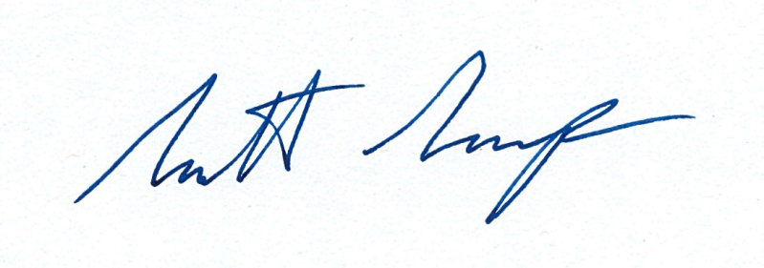Very truly yours,

By:__________________________

Scott Grosscup

Enclosures