Scott Grosscup

Office (970) 945-6546

Direct (970) 928-3468

sgrosscup@balcombgreen.com

May 2, 2019

|  |  |  |  |  |
| --- | --- | --- | --- | --- |
| Kelly Sheridan  843 County Road 6  Meeker, CO 81641 |  | Benjamin J. Rogers  P.O. Box 1083  Meeker, CO 81641 |  | Walter N. Proctor  P.O. Box 642  Meeker, CO 81641 |
| David Smith, Jr.  P.O. Box 359  Meeker, CO 81641 |  | Kai M. Turner  45840 Highway 13  Meeker, CO 81641 |  | Shawn Welder  P.O. Box 2318  Meeker, Co 81641 |
| Paul Neilson  P.O. Box 656  Meeker, CO 81641 |  | Bailey Franklin  P.O. Box. 1236  Meeker, CO 81641 |  |  |

**Re: Board Meeting – May 9, 2019**

Dear Directors:

Enclosed are materials for the Board meeting for the Yellow Jacket Water Conservancy District for Thursday, May 9, 2019 at 3:00 p.m. The meeting will be held at the Meeker Public Library and will be open to the public.

The meeting will include a discussion of the water court application to change the place of storage for Sawmill Mountain to Lake Avery. A draft application is included for your review and consideration.

Also for discussion will be appointment of new Directors. Encloased is the current director list including terms.

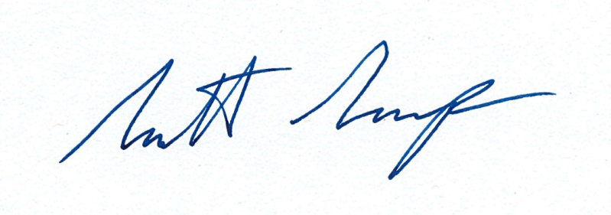Sincerely,

Scott Grosscup